This two-hour training will include details on the beginning-to-end process of Intervention Tracking and Management in Aeries. Steps shown will enable schools to track actions taken for “At Risk” students to try and prevent retention from occurring. The Pre-Referral Interventions, Referrals to Intervention, Referrals for Intervention Approval and Interventions pages can be used to assist in the prevention of academic failure through early intervention, progress measurement, and the determination of student goals.

Overview of Interventions
- Consists of four components that allow schools to document and track
- Pre-Referral Interventions
- Referrals to Interventions
- Referral Approvals
- Interventions
- Tools can be used by all staff including teachers, administrators, counselors, etc
- Can be related to student academic, behavioral, attendance, or personal/social issues
- Incorporate problem solving to identify academic problems
- Includes such programs as tutoring and before/after school classes

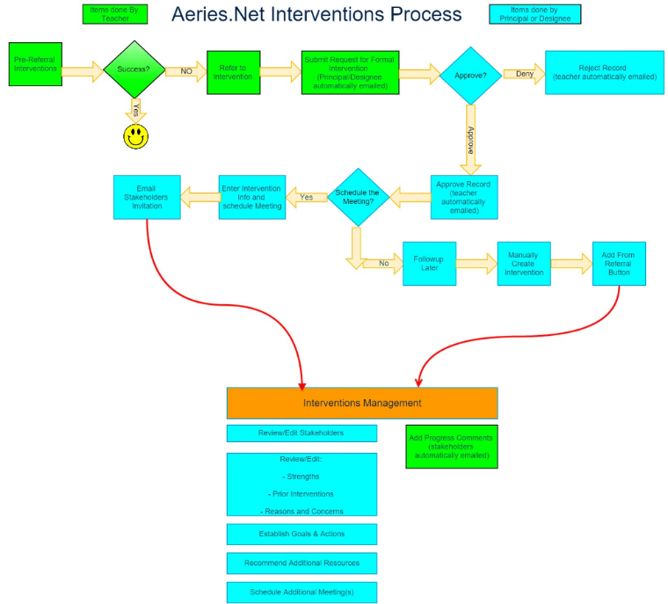

A – Intervention Management Initial Setup
- Information can be set up prior to creating Intervention records

- Set up Code Table Values in advance
- PRI, PRC, PRR, PRN, RFI, RFS, RFR, RFP, INV, IPI, IRC, ISS, INA, ING, INC, INM, INP, INS, INR, MII
B – Notification Email Setup
Node: School Info | School Options
- Setup notification to specific individuals when Intervention Referrals are submitted or approved
- Multiple email addresses can bet set up
C – Pre-Referral Interventions
Node: Student Data | Interventions | Pre-Referral Interventions
- Overview of Pre-Referral Interventions
- Can begin with teacher and include parents and other school staff
- Document classroom level strategies and interventions
- Multiple Pre-Referrals can be tracked per student by different staff members
- Includes tracking communication with parent/guardian
- Create a Pre-Referral Intervention
- Pre-Referral Details
- Date
- Staff
- School
- Comments
- Progress Status
- Progress Comments
- Interventions
- Intervention Code
- Dates
- Comments
- Reasons
- Reasons for Intervention Codes
- Comments
- Parent Meetings & Contacts
- Type of Meeting

- By Whom
- Person Contacted
- Comments

D – Referrals to Intervention
Node: Student Data | Interventions | Referral to Intervention
- Upon completion of Pre-Referral Intervention a Refer to Intervention button will display
- Upon choosing, a Referral for Intervention Details page will display
- Request for Referral for Intervention will be sent to staff emails that have been set up
- Complete details required to save and submit request
- Comments
- Person Making Request
- Title/Relationship to Student
- Date Family Notified of Referral
- Translation Services
- If box checked, dropdown of languages will appear in drop down list
- Student Strengths
- Reasons for Referral
- Prior Interventions
- Data will pull from Pre-Referral record
- Upon completion, if Pre-Referral record existed a Yes will display on the record.
- Clicking Yes link will take to Pre-Referral Record associated with referral
- Status will show Pending for student until accepted or declined

E – Referral Approval
Node: Student Data | Interventions | Referrals Approval
- User accounts with appropriate permissions can approval or deny the referral
- Details button will display Referral information in a pop up window
- Edit button can be used to add additional information
- Approve or Deny
  - If Deny clicked, a text box will ask for input on why referral being denied
  - If Approve clicked, a text box will ask for input on why approved
    - A link to Schedule the Meeting also appears
    - If meeting scheduled email will be sent with details to Stakeholders
  - Record is updated with current status on Referrals to Intervention Details page
F – Interventions
Node: Student Data | Interventions
- Displays eleven tabs on left side of page
- An Intervention record can be added with or without Referral to Intervention record
- If a Referral to Intervention was completed and approved, an Add From Referral button will display
- To create new record, either Add or Add From Referral
- Enter Intervention Record data
- Intervention Details
- Date
- Code
- Meeting Location
- Disposition
- Category, Level
- Comments
- Display to Parent
- Stakeholders
- Multiple stakeholders can include parents, teachers, counselors, agency reps, etc
- Account type of Aeries.net can be selected for district staff member
- Account type of Parent/Student can be selected for parent/student
- Stakeholders not linked to student can also be added and an email can be included
- Goals
- Used to record details regarding goals set for student intervention
- Enter description, target date, status and success
- Action can be added and include a stakeholder and are the specific steps that will be done to facilitate the goal
- Progress Comments
- Add date, code, comments
- Meetings
- Stores meeting information
- Add comments
- Add attendees
- Prior Interventions
- If record Added From Referral prior information is populated
- Reasons & Concerns
- Choose from drop downs
- Student Strengths
- Will pull from Refer to Interventions
- Additional strengths can be added
- Additional Resources
- Allow listing of resources made available to student, including equipment or items provided
- Can include outside services
- Choose from drop downs
- Practices
- Used to record instructional practices or strategies
- Identify areas needing improvement
- Choose from drop downs
- Documents
- Upload and electronically store support documentation relative to intervention
- Name document
- Choose Category and SubCategory
- Related to will populate with INV
- Locked files can only be modified or deleted by user that uploaded into system
- Copy Intervention
- Can be copied to same student or different student(s)
- Printing Interventions
- Print – Generates Interventions Report by Student
- Plan – Generates plan with all data and signature lines for stakeholders

G – Intervention Dashboard
Node: Student Data | Interventions | Intervention Dashboard
- Tool to help schools and districts analyze and recognize the frequency and distribution of various Intervention programs
- Variety of options available to filter data
- Export to Excel format
- Student results appear at bottom of form when cells on charts clicked

